The Geopolitics of Russia: Permanent Struggle
Analysis
April 15, 2012 | 13:47 GMT Print Text Size
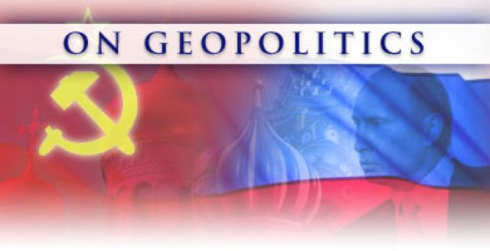

Analysis
Editor's Note: This is the fourth in a series of monographs on the geopolitics of countries influential in world affairs. This was originally published in October 2008.
Russia's defining characteristic is its indefensibility. Unlike the core of most states that are relatively defensible, core Russia is limited to the region of the medieval Grand Principality of Muscovy. It counts no rivers, oceans, swamps or mountains marking its borders — it relies solely on the relatively inhospitable climate and its forests for defense. Russian history is a chronicle of the agony of surviving invasion after invasion.
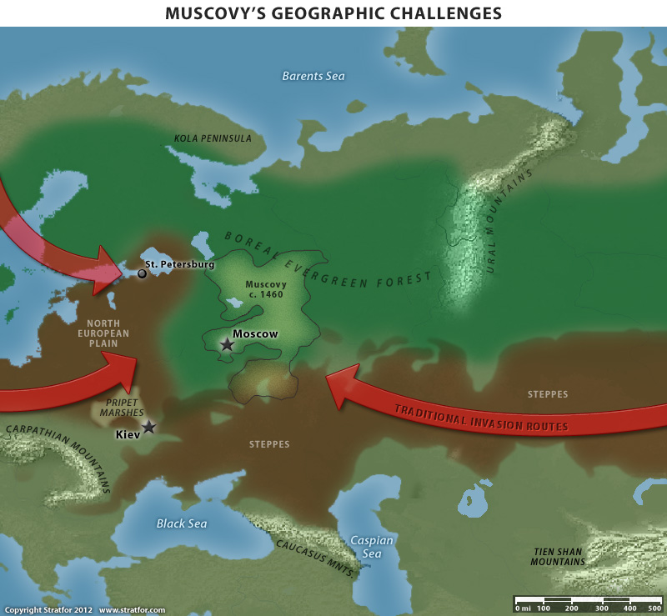
Traditionally these invasions have come from two directions. The first is from the steppes — wide open grasslands that connect Russia to Central Asia and beyond — the path that the Mongols used. The second is from the North European Plain, which brought to Russia everything from the Teutonic Knights to the Nazi war machine.
To deal with these vulnerabilities, Russia expanded in three phases. In the first, Russia expanded not toward the invasion corridors to establish buffers but away from them to establish a redoubt. In the late 15th century, under Ivan III, Russia did creep westward somewhat, anchoring itself at the Pripet Marshes, which separated Russia from the Kiev region. But the bulk of Russia's expansion during that period was north to the Arctic and northeast to the Urals. Very little of this territory can be categorized as useful — most was taiga or actual tundra and only lightly populated — but for Russia it was the only land easily up for grabs. It also marked a natural organic outgrowth of the original Muscovy — all cloaked in forest. It was as defensible a territory as Russia had access to and their only hope against the Mongols.
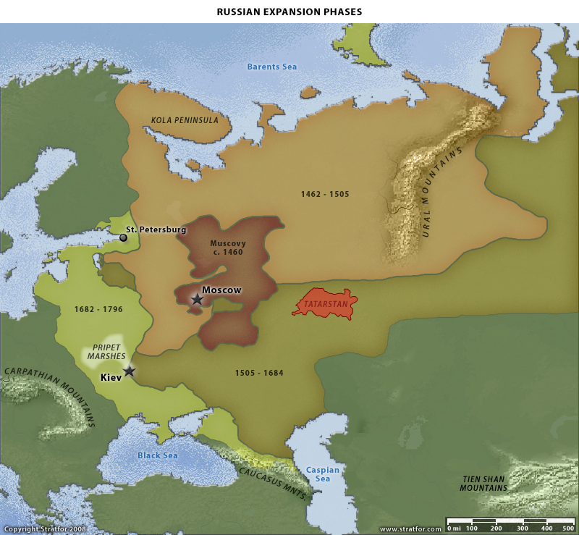
The Mongols were horsemen who dominated the grasslands with their fast-moving cavalry forces. Their power, although substantial, diminished when they entered the forests and the value of their horses, their force multipliers, declined. The Mongols had to fight infantry forces in the forests, where the advantage was on the defender's side.
The second phase of expansion was far more aggressive — and risky. In the mid-16th century, Under Ivan IV, Russia finally moved to seal off the Mongol invasion route. Russia pushed south and east, deep into the steppes, and did not stop until it hit the Urals in the east and the Caspian Sea and Caucasus Mountains in the south. As part of this expansion, Russia captured several strategically critical locations, including Astrakhan on the Caspian, the land of the Tatars — a longtime horse-mounted foe — and Grozny, which was soon transformed into a military outpost at the foot of the Caucasus.
Also with this expansion, Ivan IV was transformed from Grand Prince of Moscow to Tsar of All Russia, suggesting the empire to come. Russia had finally achieved a measure of conventional security. Holding the northern slopes of the Caucasus would provide a reasonable defense from Asia Minor and Persia, while the millions of square kilometers of steppes gave birth to another defensive strategy: buffers.
Russia — modern, medieval or otherwise — cannot count on natural features to protect it. The Pripet Marshes were small and could in many cases simply be avoided. There is no one who might wish to attack from the Arctic. Forests slowed the Mongol horsemen, but as Muscovy's predecessor — Kievan Rus — aptly demonstrated, the operative word was “slowed,” not “stopped.” The Mongols conquered and destroyed Kievan Rus in the 13th century.
That leaves buffers. So long as a country controls territory separating itself from its foes — even if it is territory that is easy for a hostile military to transit — it can bleed out any invasion via attrition and attacks on supply lines. Such buffers, however, contain a poison pill. They have populations not necessarily willing to serve as buffers. Maintaining control of such buffers requires not only a sizable standing military for defense but also a huge internal security and intelligence network to enforce central control. And any institution so key to the state's survival must be very tightly controlled as well. Establishing and maintaining buffers not only makes Russia seem aggressive to its neighbors but also forces it to conduct purges and terrors against its own institutions in order to maintain the empire.
The third expansion phase dealt with the final invasion route: from the west. In the 18th century, under Peter and Catherine the Great, Russian power pushed westward, conquering Ukraine to the southwest and pushing on to the Carpathian Mountains. It also moved the Russian border to the west, incorporating the Baltic territories and securing a Russian flank on the Baltic Sea. Muscovy and the Tsardom of Russia were now known as the Russian Empire.
Yet aside from the anchor in the Carpathians, Russia did not achieve any truly defensible borders. Expansions to the Baltic and Black Seas did end the external threat from the Cossacks and Balts of ages past, but at the price of turning those external threats into internal ones. Russia also expanded so far and fast that holding the empire together socially and militarily became a monumental and ongoing challenge (today Russia is dealing with the fact that Russians are barely a majority in their own country). All this to achieve some semblance of security by establishing buffer regions.
But that is an issue of empire management. Ultimately the multi-directional threat defined Muscovy's geopolitical problem. There was a constant threat from the steppes, but there was also a constant threat from the west, where the North European Plain allowed for few natural defenses and larger populations could deploy substantial infantry (and could, as the Swedes did, use naval power to land forces against the Muscovites). The forests provided a degree of protection, as did the sheer size of Russia's holdings and its climate, but in the end the Russians faced threats from at least two directions. In managing these threats by establishing buffers, they were caught in a perpetual juggling act: east vs. west, internal vs. external.
The geography of the Russian Empire bequeathed it certain characteristics. Most important, the empire was (and remains) lightly settled. Even today, vast areas of Russia are unpopulated while in the rest of the country the population is widely distributed in small towns and cities and far less concentrated in large urban areas. Russia's European part is the most densely populated, but in its expansion Russia both resettled Russian ethnics and assimilated large minorities along the way. So while Moscow and its surroundings are certainly critical, the predominance of the old Muscovy is not decisively ironclad.
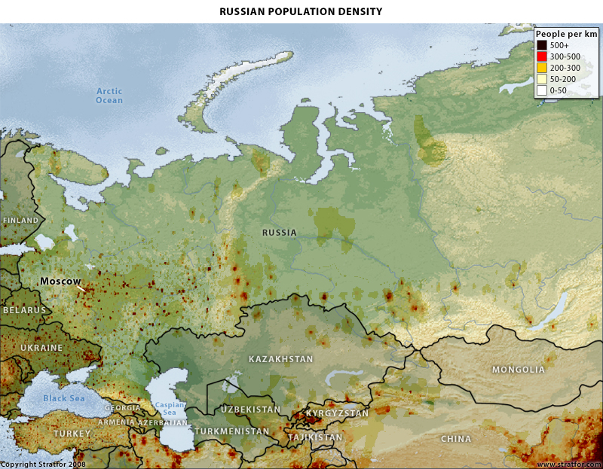
The result is a constant, ingrained clash within the Russian Empire no matter the time frame, driven primarily by its size and the challenges of transport. The Russian empire, even excluding Siberia, is an enormous landmass located far to the north. Moscow is at the same latitude as Newfoundland while the Russian and Ukrainian breadbaskets are at the latitude of Maine, resulting in an extremely short growing season. Apart from limiting the size of the crop, the climate limits the efficiency of transport — getting the crop from farm to distant markets is a difficult matter and so is supporting large urban populations far from the farms. This is the root problem of the Russian economy. Russia can grow enough to feed itself, but it cannot efficiently transport what it grows from the farms to the cities and to the barren reaches of the empire before the food spoils. And even when it can transport it, the costs of transport make the foodstuffs unaffordable.
Population distribution also creates a political problem. One natural result of the transport problem is that the population tends to distribute itself nearer growing areas and in smaller towns so as not to tax the transport system. Yet these populations in Russia's west and south tend to be conquered peoples. So the conquered peoples tend to distribute themselves to reflect economic rationalities, while need for food to be transported to the Russian core goes against such rationalities.
Faced with a choice of accepting urban starvation or the forcing of economic destitution upon the food-producing regions (by ordering the sale of food in urban centers at prices well below market prices), Russian leaders tend to select the latter option. Joseph Stalin certainly did in his efforts to forge and support an urban, industrialized population. Force- feeding such economic hardship to conquered minorities only doubled the need for a tightly controlled security apparatus.
The Russian geography meant that Russia either would have a centralized government — and economic system — or it would fly apart, torn by nationalist movements, peasant uprisings and urban starvation. Urbanization, much less industrialization, would have been impossible without a strong center. Indeed, the Russian Empire or Soviet Union would have been impossible. The natural tendency of the empire and Russia itself is to disintegrate. Therefore, to remain united it had to have a centralized bureaucracy responsive to autocratic rule in the capital and a vast security apparatus that compelled the country and empire to remain united. Russia's history is one of controlling the inherently powerful centrifugal forces tearing at the country's fabric.
Russia, then, has two core geopolitical problems. The first is holding the empire together. But the creation of that empire poses the second problem, maintaining internal security. It must hold together the empire and defend it at the same time, and the achievement of one goal tends to undermine efforts to achieve the other.
Geopolitical Imperatives
To secure the Russian core of Muscovy, Russia must:
• Expand north and east to secure a redoubt in climatically hostile territory that is protected in part by the Urals. This way, even in the worst-case scenario (i.e., Moscow falls), there is still a “Russia” from which to potentially resurge.
• Expand south to the Caucasus and southeast into the steppes in order to hamper invasions of Asian origin. As circumstances allow, push as deeply into Central Asia and Siberia as possible to deepen this bulwark.
• Expand as far west as possible. Do not stop in the southwest until the Carpathians are reached. On the North European Plain do not stop ever. Deeper penetration increases security not just in terms of buffers; the North European Plain narrows the further west one travels making its defense easier.
• Manage the empire with terror. Since the vast majority of Russian territory is not actually Russian, a very firm hand is required to prevent myriad minorities from asserting regional control or aligning with hostile forces.
• Expand to warm water ports that have open-ocean access so that the empire can begin to counter the economic problems that a purely land empire suffers.
Given the geography of the Russian heartland, we can see why the Russians would attempt to expand as they did. Vulnerable to attack on the North European Plain and from the Central Asian and European steppes simultaneously, Russia could not withstand an attack from one direction — much less two. Apart from the military problem, the ability of the state to retain control of the country under such pressure was dubious, as was the ability to feed the country under normal circumstances — much less during war. Securing the Caucasus, Central Asia and Siberia was the first — and easiest — part of dealing with this geographic imbroglio.
The western expansion was not nearly so "simple." No matter how far west the Russians moved on the European plain, there was no point at which they could effectively anchor themselves. Ultimately, the last effective line of defense is the 400 mile gap (aka Poland) between the Baltic Sea and Carpathian Mountains. Beyond that the plains widen to such a degree that a conventional defense is impossible as there is simply too much open territory to defend. So the Soviet Union pressed on all the way to the Elbe.
At its height, the Soviet Union achieved all but its final imperative of securing ocean access. The USSR was anchored on the Carpathians, the Black Sea, the Caucasus and the Urals, all of which protected its southern and southwestern flanks. Siberia protected its eastern frontier with vast emptiness. Further to the south, Russia was anchored deeply in Central Asia. The Russians had defensible frontiers everywhere except the North European Plain, ergo the need to occupy Germany and Poland.

Strategy of the Russian Empire
The modern Russian empire faces three separate border regions: Asian Siberia, Central Asia and the Caucasus (now mostly independent states), and Western Europe.
First, Siberia. There is only one rail line connecting Siberia to the rest of the empire, and positioning a military force there is difficult if not impossible. In fact, risk in Russia's far east is illusory. The Trans-Siberian Railroad (TSR) runs east-west, with the Baikal Amur Mainline forming a loop. The TSR is Russia's main lifeline to Siberia and is, to some extent, vulnerable. But an attack against Siberia is difficult — there is not much to attack but the weather, while the terrain and sheer size of the region make holding it not only difficult but of questionable relevance. Besides, an attack beyond it is impossible because of the Urals.
East of Kazakhstan, the Russian frontier is mountainous to hilly, and there are almost no north-south roads running deep into Russia; those that do exist can be easily defended, and even then they dead-end in lightly populated regions. The period without mud or snow lasts less than three months out of the year. After that time, overland resupply of an army is impossible. It is impossible for an Asian power to attack Siberia. That is the prime reason the Japanese chose to attack the United States rather than the Soviet Union in 1941. The only way to attack Russia in this region is by sea, as the Japanese did in 1905. It might then be possible to achieve a lodgment in the maritime provinces (such as Primorsky Krai or Vladivostok). But exploiting the resources of deep Siberia, given the requisite infrastructure costs, is prohibitive to the point of being virtually impossible.
We begin with Siberia in order to dispose of it as a major strategic concern. The defense of the Russian Empire involves a different set of issues.
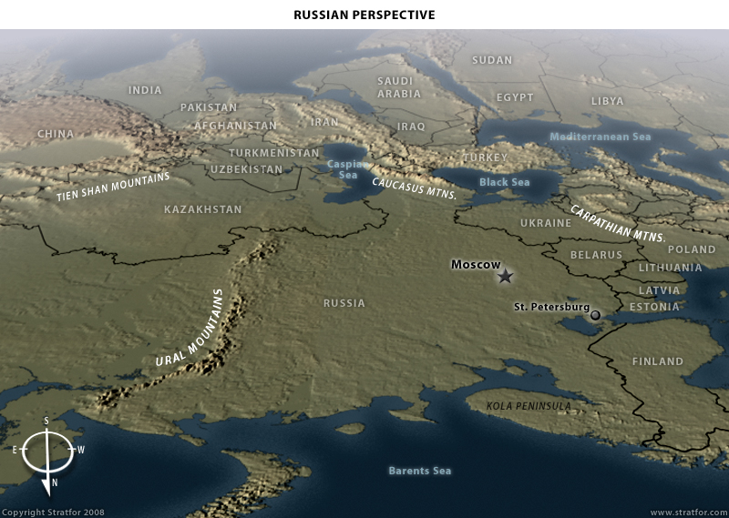
Second, Central Asia. The mature Russian Empire and the Soviet Union were anchored on a series of linked mountain ranges, deserts and bodies of water in this region that gave it a superb defensive position. Beginning on the northwestern Mongolian border and moving southwest on a line through Kyrgyzstan and Tajikistan, the empire was guarded by a north extension of the Himalayas, the Tien Shan Mountains. Swinging west along the Afghan and Iranian borders to the Caspian Sea, the empire occupied the lowlands along a mountainous border. But the lowlands, except for a small region on the frontier with Afghanistan, were harsh desert, impassable for large military forces. A section along the Afghan border was more permeable, leading to a long-term Russian unease with the threat in Afghanistan — foreign or indigenous. The Caspian Sea protected the border with Iran, and on its western shore the Caucasus Mountains began, which the empire shared with Iran and Turkey but which were hard to pass through in either direction. The Caucasus terminated on the Black Sea, totally protecting the empire's southern border. These regions were of far greater utility to Russia than Siberia and so may have been worth taking, but for once geography actually helped Russia instead of working against it.
Finally, there is the western frontier that ran from west of Odessa north to the Baltic. This European frontier was the vulnerable point. Geographically, the southern portion of the border varied from time to time, and where the border was drawn was critical. The Carpathians form an arc from Romania through western Ukraine into Slovakia. Russia controlled the center of the arc in Ukraine. However, its frontier did not extend as far as the Carpathians in Romania, where a plain separated Russia from the mountains. This region is called Moldova or Bessarabia, and when the region belongs to Romania, it represents a threat to Russian national security. When it is in Russian hands, it allows the Russians to anchor on the Carpathians. And when it is independent, as it is today in the form of the state of Moldova, then it can serve either as a buffer or a flash point. During the alliance with the Germans in 1939-1941, the Russians seized this region as they did again after World War II. But there is always a danger of an attack out of Romania.
This is not Russia's greatest danger point. That occurs further north, between the northern edge of the Carpathians and the Baltic Sea. This gap, at its narrowest point, is just under 300 miles, running west of Warsaw from the city of Elblag in northern Poland to Cracow in the south. This is the narrowest point in the North European Plain and roughly the location of the Russian imperial border prior to World War I. Behind this point, the Russians controlled eastern Poland and the three Baltic countries.
The danger to Russia is that the north German plain expands like a triangle east of this point. As the triangle widens, Russian forces get stretched thinner and thinner. So a force attacking from the west through the plain faces an expanding geography that thins out Russian forces. If invaders concentrate their forces, the attackers can break through to Moscow. That is the traditional Russian fear: Lacking natural barriers, the farther east the Russians move the broader the front and the greater the advantage for the attacker. The Russians faced three attackers along this axis following the formation of empire — Napoleon, Wilhelm II and Hitler. Wilhelm was focused on France so he did not drive hard into Russia, but Napoleon and Hitler did, both almost toppling Moscow in the process.
Along the North European Plain, Russia has three strategic options:
1. Use Russia's geographical depth and climate to suck in an enemy force and then defeat it, as it did with Napoleon and Hitler. After the fact this appears the solution, except it is always a close run and the attackers devastate the countryside. It is interesting to speculate what would have happened in 1942 if Hitler had resumed his drive on the North European Plain toward Moscow, rather than shift to a southern attack toward Stalingrad.
2. Face an attacking force with large, immobile infantry forces at the frontier and bleed them to death, as they tried to do in 1914. On the surface this appears to be an attractive choice because of Russia's greater manpower reserves than those of its European enemies. In practice, however, it is a dangerous choice because of the volatile social conditions of the empire, where the weakening of the security apparatus could cause the collapse of the regime in a soldiers' revolt as happened in 1917.
3. Push the Russian/Soviet border as far west as possible to create yet another buffer against attack, as the Soviets did during the Cold War. This is obviously an attractive choice, since it creates strategic depth and increases economic opportunities. But it also diffuses Russian resources by extending security states into Central Europe and massively increasing defense costs, which ultimately broke the Soviet Union in 1992.

Contemporary Russia
The greatest extension of the Russian Empire occurred under the Soviets from 1945 to 1989. Paradoxically, this expansion preceded the collapse of the Soviet Union and the contraction of Russia to its current borders. When we look at the Russian Federation today, it is important to understand that it has essentially retreated to the borders the Russian Empire had in the 17th century. It holds old Muscovy plus the Tatar lands to the southeast as well as Siberia. It has lost its western buffers in Ukraine and the Baltics and its strong foothold in the Caucasus and in Central Asia.
To understand this spectacular expansion and contraction, we need to focus on Soviet strategy. The Soviet Union was a landlocked entity dominating the Eurasian heartland but without free access to the sea. Neither the Baltic nor Black seas allow Russia free oceangoing transport because they are blocked by the Skagerrak and the Turkish straits, respectively. So long as Denmark and Turkey remain in NATO, Russia's positions in St. Petersburg, Kaliningrad, Sevastopol and Novorossiysk are militarily dubious.
There were many causes of the Soviet collapse. Some were:
- Overextending forces into Central Europe, which taxed the ability of the Soviet Union to control the region while economically exploiting it. It became a net loss. This overextension created costly logistical problems on top of the cost of the military establishment. Extension of the traditional Russian administrative structure both diffused Russia's own administrative structure and turned a profitable empire into a massive economic burden.
- Creating an apparent threat to the rest of Europe that compelled the United States to deploy major forces and arm Germany. This in turn forced the Russians into a massive military buildup that undermined its economy, which was less productive than the American economy because of its inherent agricultural problem and because the cost of internal transport combined with the lack of ocean access made Soviet (and Russian) maritime trade impossible. Since maritime trade both is cheaper than land trade and allows access to global markets, the Soviet Union always operated at an extreme economic disadvantage to its Western and Asian competitors.
- Entering an arms race with much richer countries it could compete against only by diverting resources from the civilian economy — material and intellectual. The best minds went into the military-industrial complex, causing the administrative and economic structure of Russia to crumble.
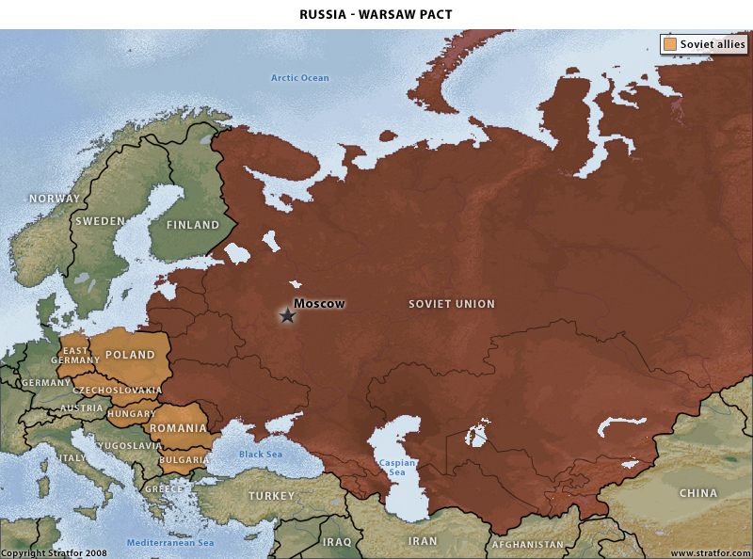
In 1989 the Soviet Union lost control of Eastern Europe and in 1992 the Soviet Union itself collapsed. Russia then retreated essentially to its 17th century borders — except that it retained control of Siberia, which is either geopolitically irrelevant or a liability. Russia has lost all of Central Asia, and its position in the Caucasus has become tenuous. Had Russia lost Chechnya, its eastern flank would have been driven out of the Caucasus completely, leaving it without a geopolitical anchor.
The gap between Kazakhstan in the east and Ukraine in the west, like the narrowest point in the North European Plain, is only 300 miles wide. It also contains Russia's industrial heartland. Russia has lost Ukraine, of course, and Moldova. But Russia's most grievous geopolitical contraction has been on the North European Plain, where it has retreated from the Elbe in Germany to a point less than 100 miles from St. Petersburg. The distance from the border of an independent Belarus to Moscow is about 250 miles.
To understand the Russian situation, it is essential to understand that Russia has in many ways returned to the strategic position of late Muscovy. Its flank to the southeast is relatively secure, since China shows no inclination for adventures into the steppes, and no other power is in a position to challenge Russia from that direction. But in the west, in Ukraine and in the Caucasus, the Russian retreat has been stunning.
We need to remember why Muscovy expanded in the first place. Having dealt with the Mongols, the Russians had two strategic interests. Their most immediate was to secure their western borders by absorbing Lithuania and anchoring Russia as far west on the North European Plain as possible. Their second strategic interest was to secure Russia's southeastern frontier against potential threats from the steppes by absorbing Central Asia as well as Ukraine. Without that, Muscovy could not withstand a thrust from either direction, let alone from both directions at once.
It can be said that no one intends to invade Russia. From the Russian point of view, history is filled with dramatic changes of intention, particularly in the West. The unthinkable occurs to Russia once or twice a century. In its current configuration, Russia cannot hope to survive whatever surprises are coming in the 21st century. Muscovy was offensive because it did not have a good defensive option. The same is true of Russia. Given the fact that a Western alliance, NATO, is speaking seriously of establishing a dominant presence in Ukraine and in the Caucasus — and has already established a presence in the Baltics, forcing Russia far back into the widening triangle, with its southern flank potentially exposed to Ukraine as a NATO member — the Russians must view their position as dire. As with Napoleon, Wilhelm and Hitler, the initiative is in the hands of others. For the Russians, the strategic imperative is to eliminate that initiative or, if that is impossible, anchor Russia as firmly as possible on geographical barriers, concentrating all available force on the North European Plain without overextension.
Unlike countries such as China, Iran and the United States, Russia has not achieved its strategic geopolitical imperatives. On the contrary, it has retreated from them:
- Russia does hold the northern Caucasus, but it no longer boasts a deep penetration of the mountains, including Georgia and Armenia. Without those territories Russia cannot consider this flank secure.
- Russia has lost its anchor in the mountains and deserts of Central Asia and so cannot actively block or disrupt — or even well monitor — any developments to its deep south that could threaten its security.
- Russia retains Siberia, but because of the climatic and geographic hostility of the region it is almost a wash in terms of security (it certainly is economically).
- Russia's loss of Ukraine and Moldova allows both the intrusion of other powers and the potential rise of a Ukrainian rival on its very doorstep. Powers behind the Carpathians are especially positioned to take advantage of this political geography.
- The Baltic states have re-established their independence, and all three are east and north of the Baltic-Carpathian line (the final defensive line on the North European Plain). Their presence in a hostile alliance is unacceptable. Neither is an independent or even neutral Belarus (also on the wrong side of that line).
Broader goals, such as having a port not blocked by straits controlled by other countries, could have been pursued by the Soviets. Today such goals are far out of Russian reach. From the Russian point of view, creating a sphere of influence that would return Russia to its relatively defensible imperial boundaries is imperative.
Obviously, forces in the peripheral countries as well as great powers outside the region will resist. For them, a weak and vulnerable Russia is preferable, since a strong and secure one develops other appetites that could see Russia pushing along vectors such as through the Skagerrak toward the North Sea, through the Turkish Straits toward the Mediterranean and through La Perouse Strait toward Japan and beyond.
Russia's essential strategic problem is this: It is geopolitically unstable. The Russian Empire and Soviet Union were never genuinely secure. One problem was the North European Plain. But another problem, very real and hard to solve, was access to the global trading system via oceans. And behind this was Russia's essential economic weakness due to its size and lack of ability to transport agricultural produce throughout the country. No matter how much national will it has, Russia's inherently insufficient infrastructure constantly weakens its internal cohesion.
Russia must dominate the Eurasian heartland. When it does, it must want more. The more it wants the more it must face its internal economic weakness and social instability, which cannot support its ambitions. Then the Russian Federation must contract. This cycle has nothing to do with Russian ideology or character. It has everything to do with geography, which in turn generates ideologies and shapes character. Russia is Russia and must face its permanent struggle.
Read more: The Geopolitics of Russia: Permanent Struggle | Stratfor
Follow us: @stratfor on Twitter | Stratfor on Facebook

